**Final Project Milestone**

For the first network graph(the completed one), when you click the node, it will show the corresponding athletes details of selected country or selected sport in the following charts. The default is swimming and CHN, so every time you click a node, it will update either selected country or selected sport and the other one remains.

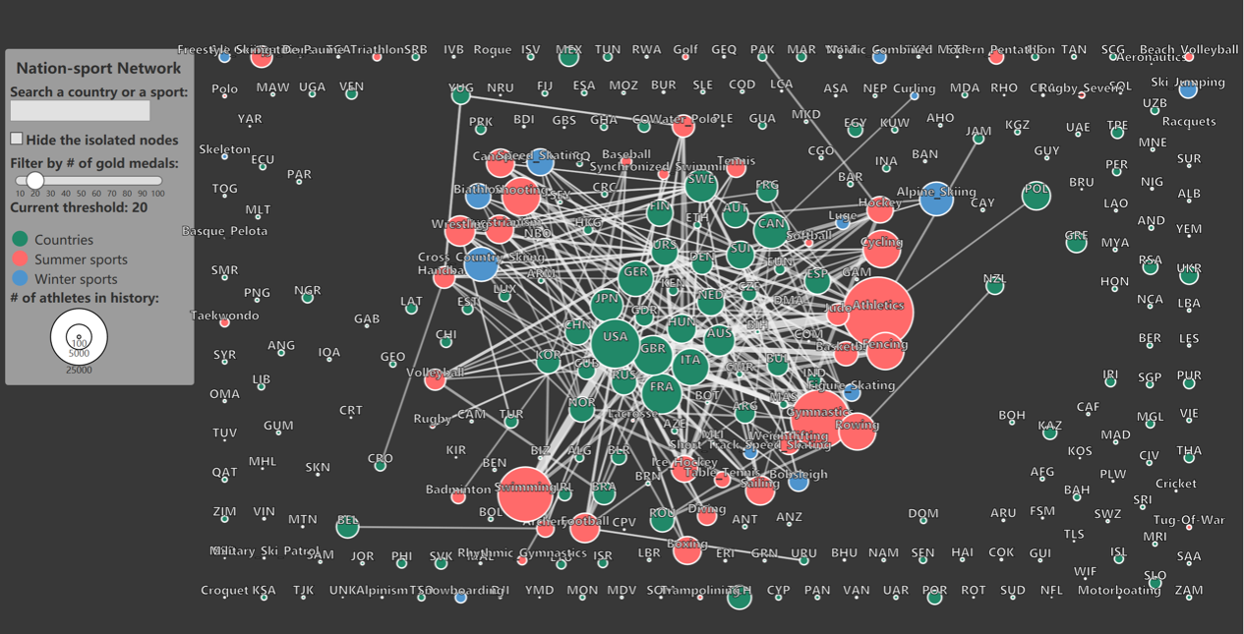

Parallel coordinate Chartis based on the idea that displaying athletes’ physical qualities and their result. There are two more ever displayed white lines represent the perfect athlete’s physical quality which was scientifically calculated by weighting algorithm (average gold’s physical quality 50%+average silver’s physical quality*30%+average bronze’s physical quality *20%).

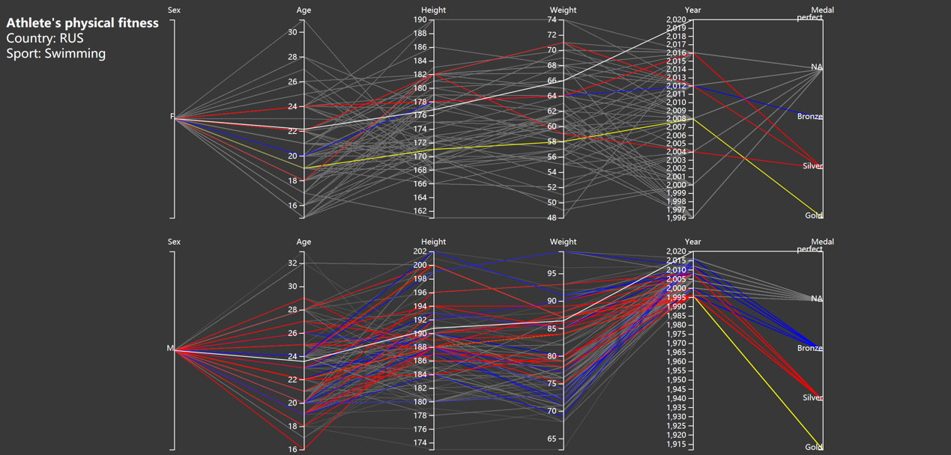

Chart 3 was come up with the idea that to show each athlete’s career time. For the specific sport in specific country. When an athlete started participating the game, the dot appeared on the correspond year (Y axis defines each athlete), if they continue participating, the line will move till the year which was the last year they participated the game. Users can choose to sort the dots and lines to see athletes of longer career time on the top.

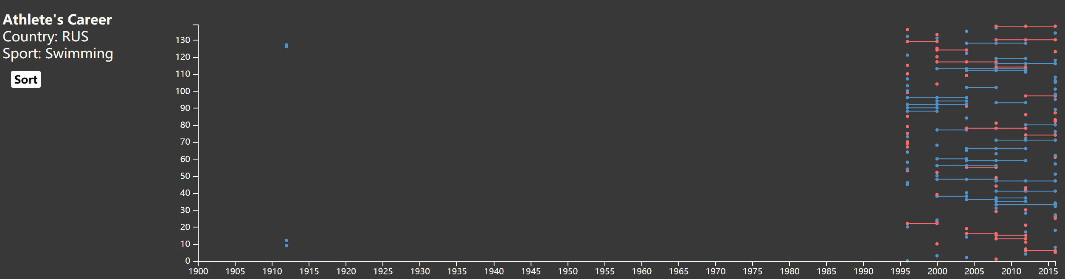

We are still trying to achieve link between chart 2 and 3, so that when we choose some dots in chart 3(with brush), the corresponding athletes’ line in chart 2 will be highlight. And vice versa.